**KamiKoto – Stationery E‑Commerce Web Application**

**Project Documentation**

**Team:**

22PA1A05I7, 22PA1A05G5, 22PA1A05E7, 22PA1A05F9, 22PA1A05I0

**Introduction:**

KamiKoto is a full-featured, responsive e-commerce web application focused on selling curated stationery and desk accessories. The platform emphasizes modern UI/UX principles, real-world web application architecture, and a clean shopping experience inspired by leading minimalist design trends. Built using contemporary web development tools, KamiKoto allows users to browse a catalog of products, manage user accounts, and complete purchases, while also providing an administrative interface for product and user management.

**Objective:**

The primary objective of this project is to develop a scalable and user-friendly e-commerce platform that:

* Allows users to browse and purchase stationery products through a secure and intuitive interface.
* Provides product search, filtering, and promotional offers to enhance user experience.
* Includes account-based functionality such as login, registration, and profile management.
* Enables real-time cart management and a checkout process with email confirmations.
* Empowers administrators with tools for inventory and user management through a dedicated panel.
* Demonstrates strong frontend responsiveness and maintainable backend integrations.

**Technology Stack:**

|  |  |
| --- | --- |
| **Component** | **Technology Used** |
| Frontend Framework | React.js |
| Styling | Tailwind CSS |
| State Management | React Context API |
| Authentication | Firebase Authentication |
| Database | Firebase Firestore (NoSQL) |
| Email Services | Cloudflare Workers with Resend API |
| Deployment Platform | Cloudflare Pages |
| Version Control | Git and GitHub |

**Key Features:**

**Product Listings:**

• Products are displayed with thumbnails, pricing, stock status, and brand details.

• Out-of-stock items and discounts are visually tagged.

• Quick navigation and smooth transitions are implemented for ease of browsing.

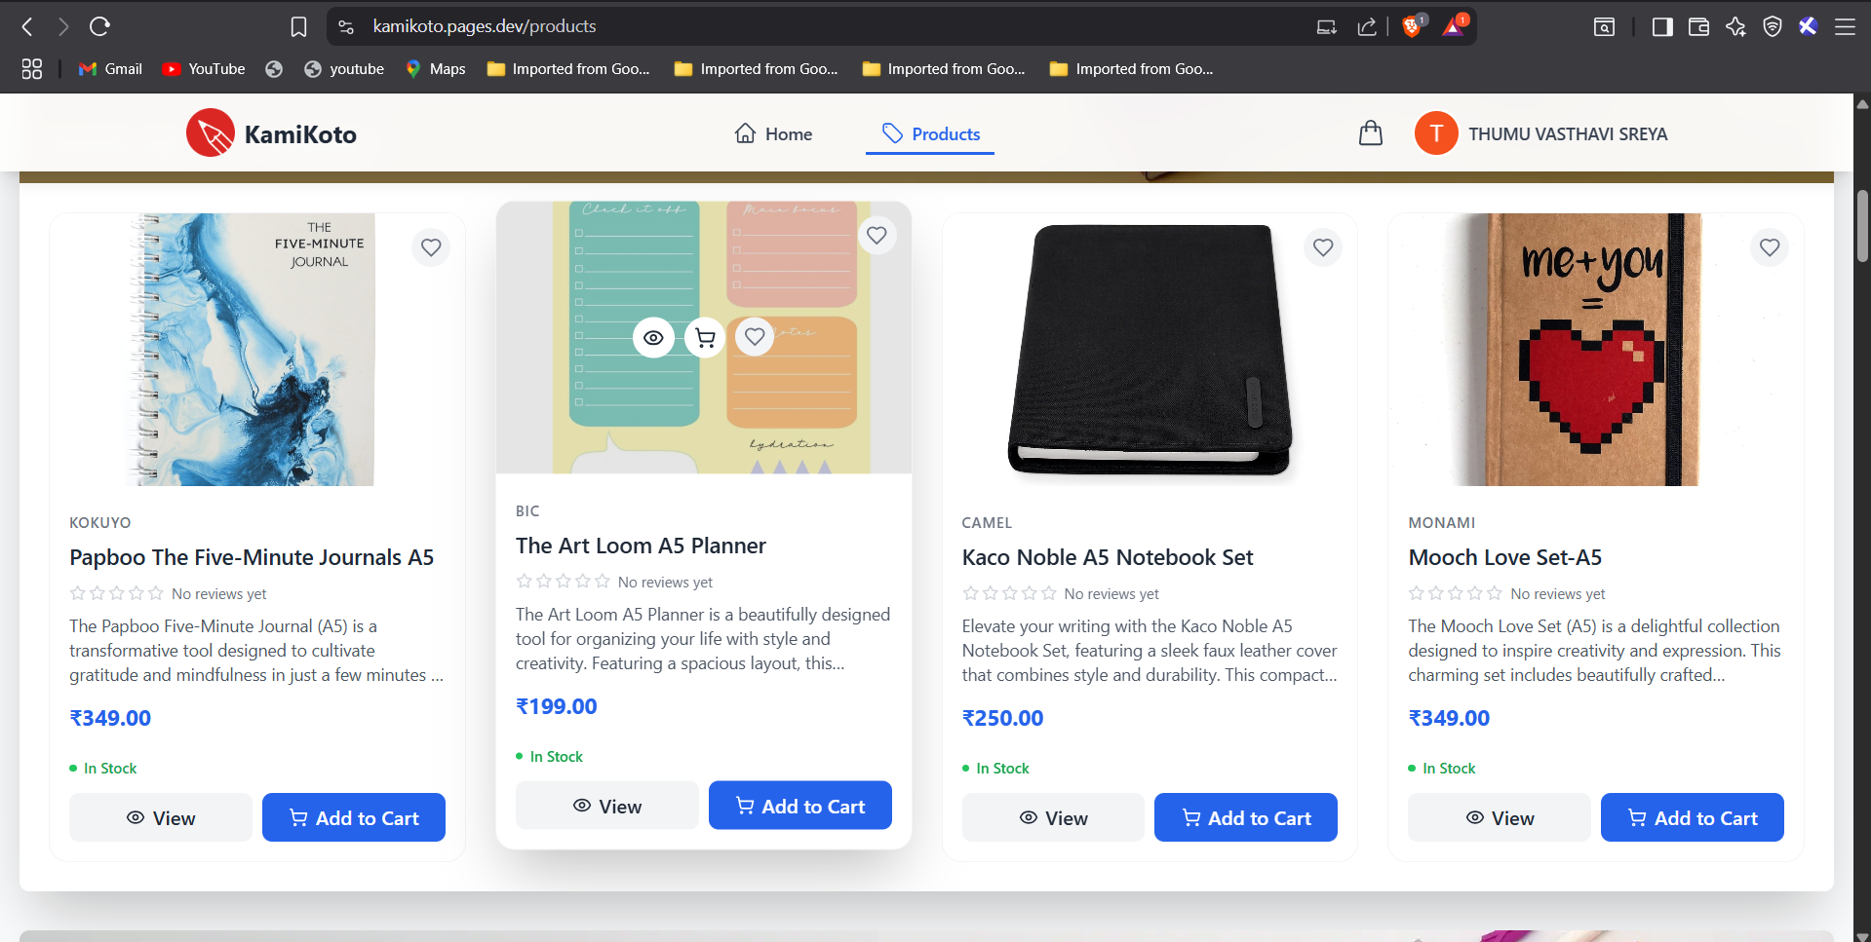

**Shopping Cart and Checkout:**

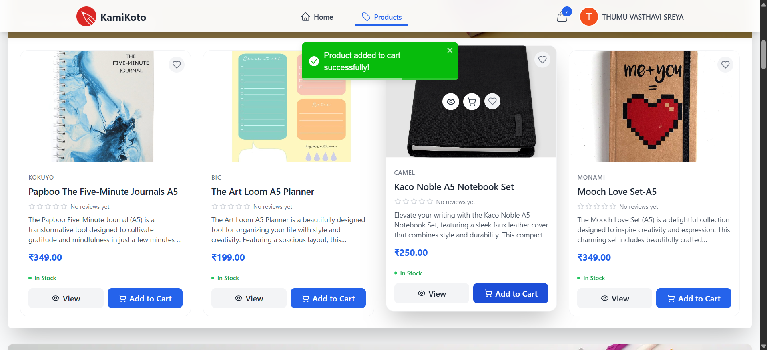

* Authentication is handled using Firebase Authentication.
* Supports email/password login and OAuth with Google and GitHub.
* Persistent sessions are maintained across browser reloads.
* Users can securely reset passwords via email recovery.
* Protected routes restrict access to authenticated users only.
* Admin privileges are granted based on Firestore role checks (userRole: "Admin").

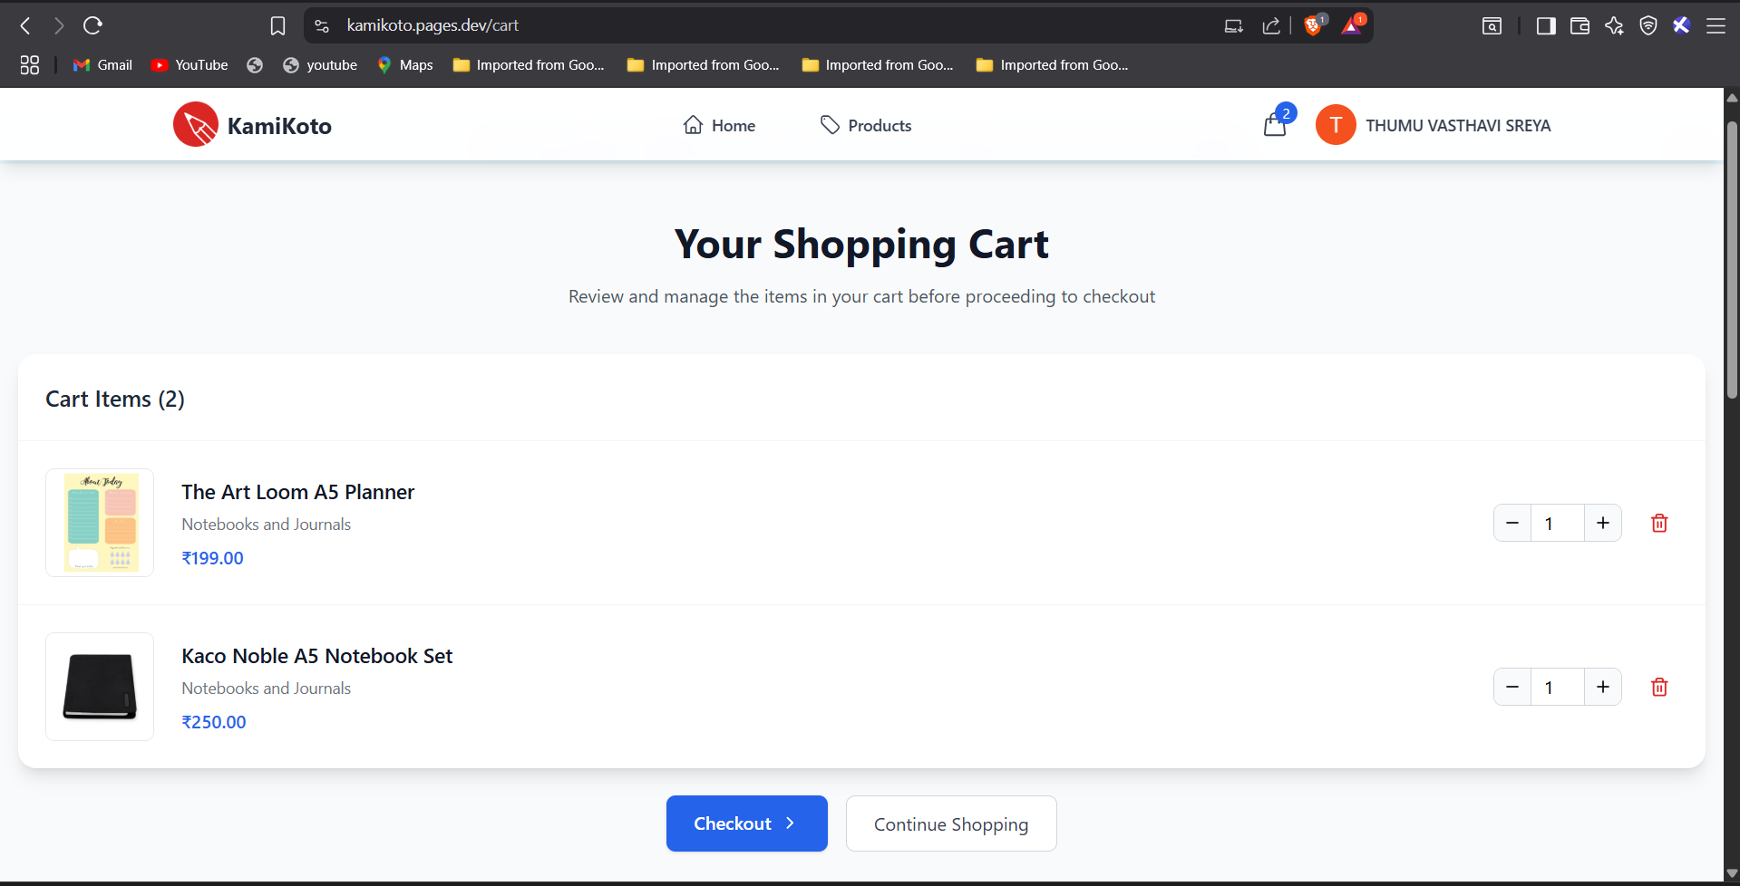

**User Authentication:**

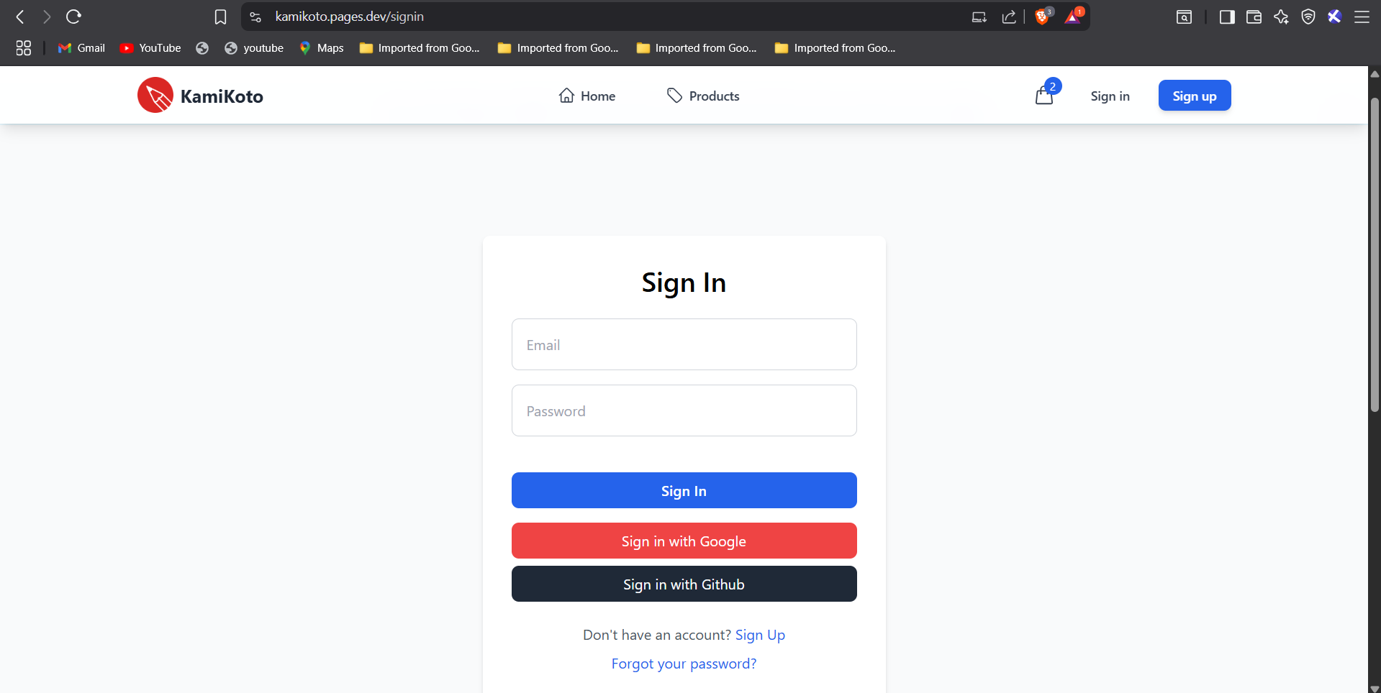

* Secure sign-up and login using email/password credentials.
* OAuth support via Google and GitHub for ease of access.
* Password reset and session management implemented using Firebase Authentication.

**Email Notification System:**

* Cloudflare Workers handle server-side email communication to prevent CORS issues.
* Order confirmations and updates are dispatched using the Resend API.
* Configured using secure environment variables during deployment.

**Admin Dashboard (Separate Panel):**

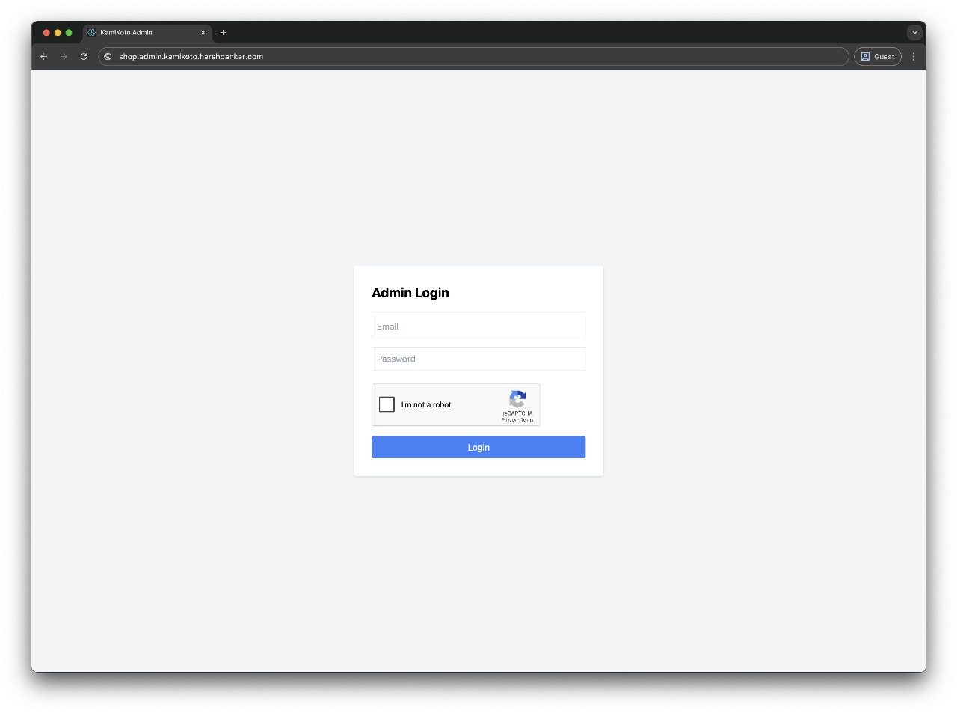

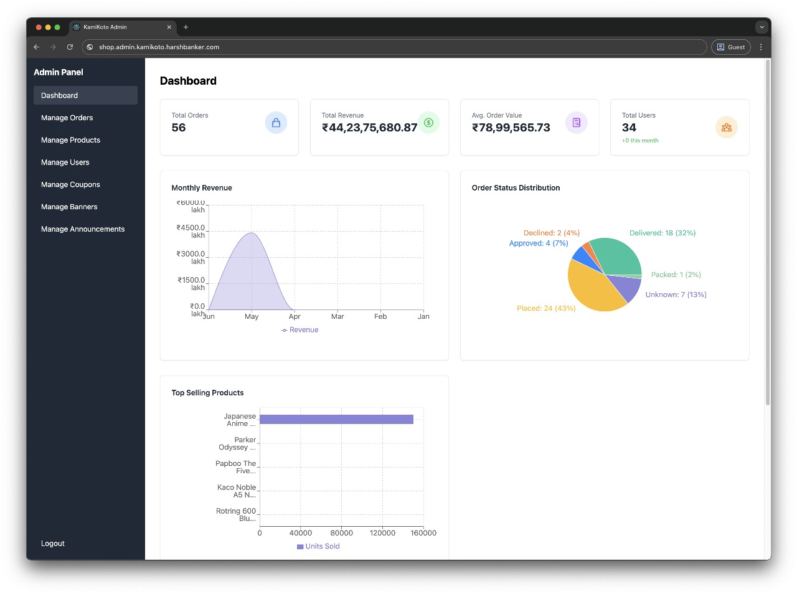

* Admins are authenticated by verifying a special userRole field in Firestore.

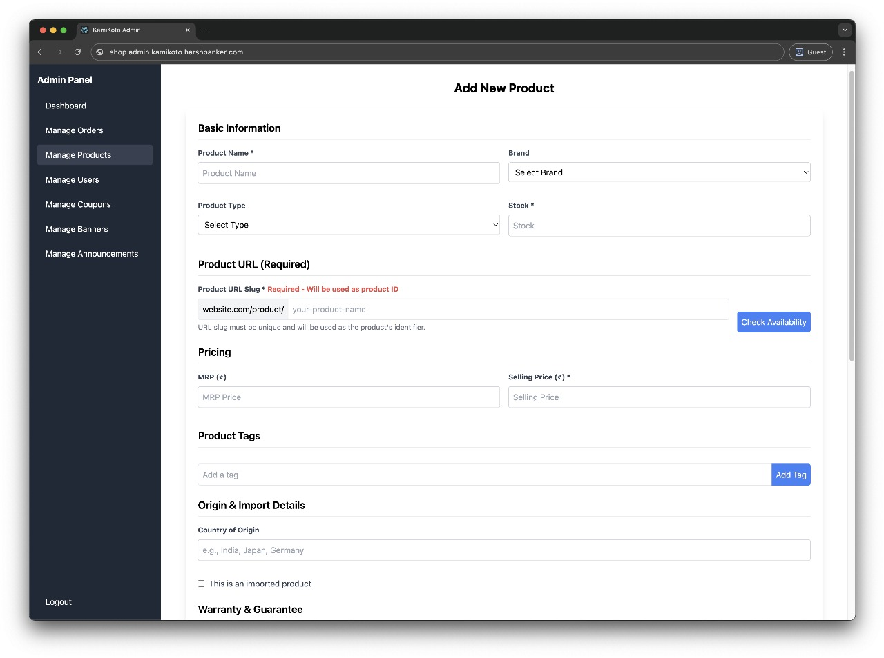

* Admins can create, edit, and delete product entries.

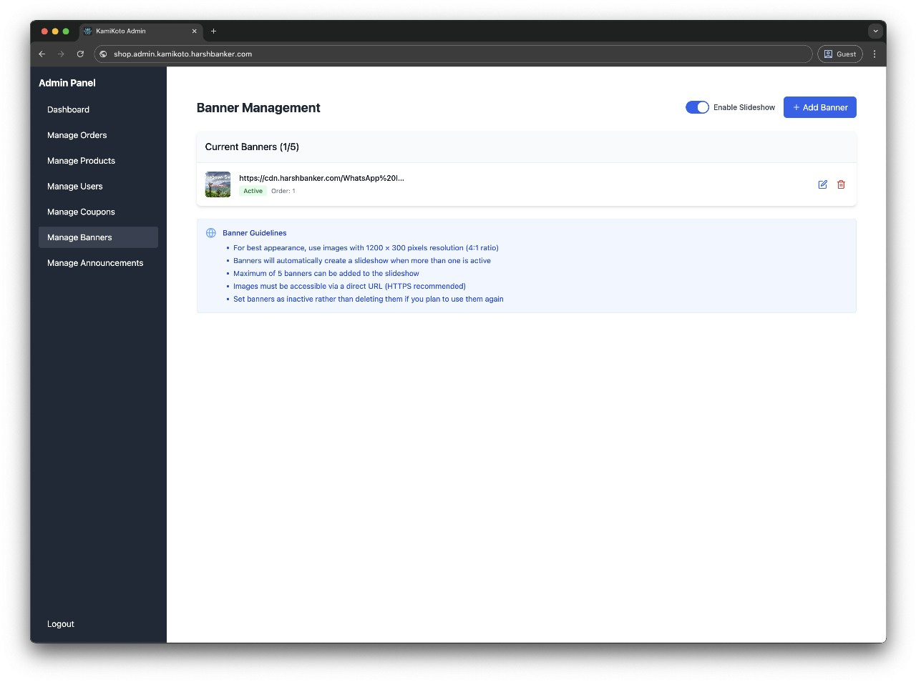

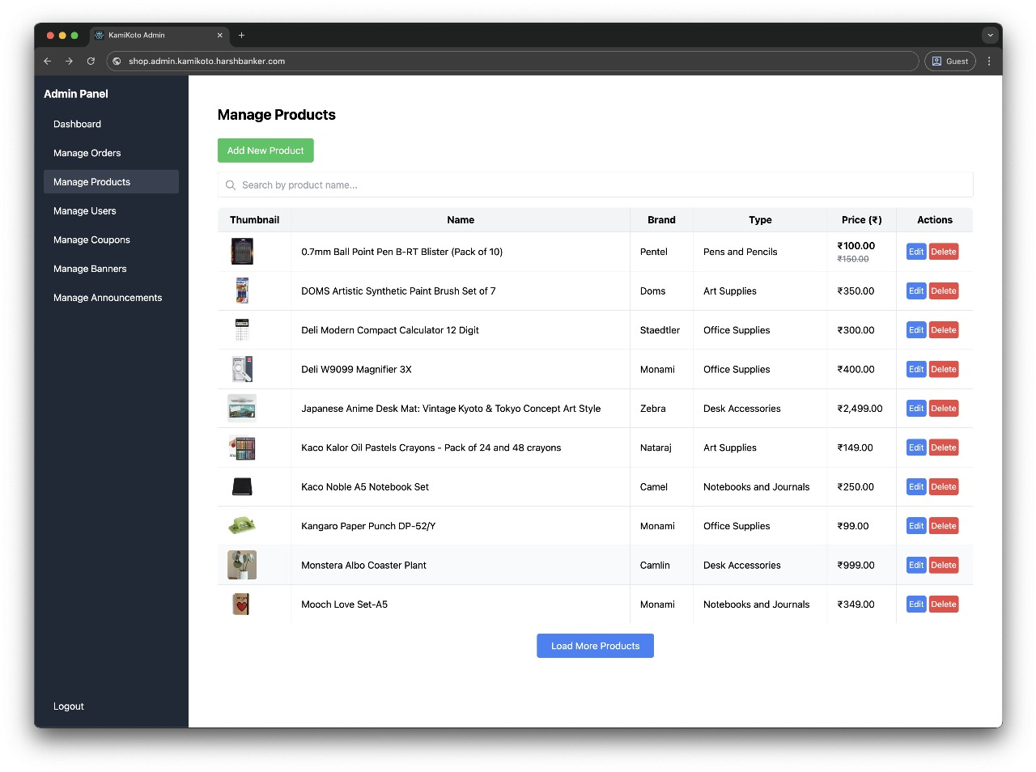

* Ability to feature products, manage inventory, and oversee users.

**Responsive Design:**

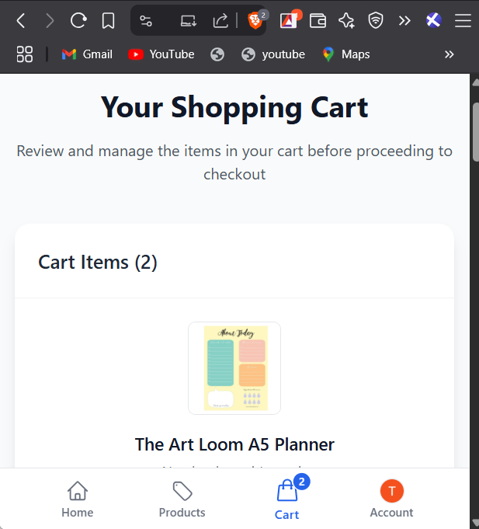

* Layouts adapt seamlessly across desktop, tablet, and mobile devices.
* Optimized using Tailwind CSS utility classes and a mobile-first design approach.

**Promotional Banners:**

* Promotional messages such as seasonal sales or coupon codes are dynamically displayed.
* Supports visual and text-based banners on the home page

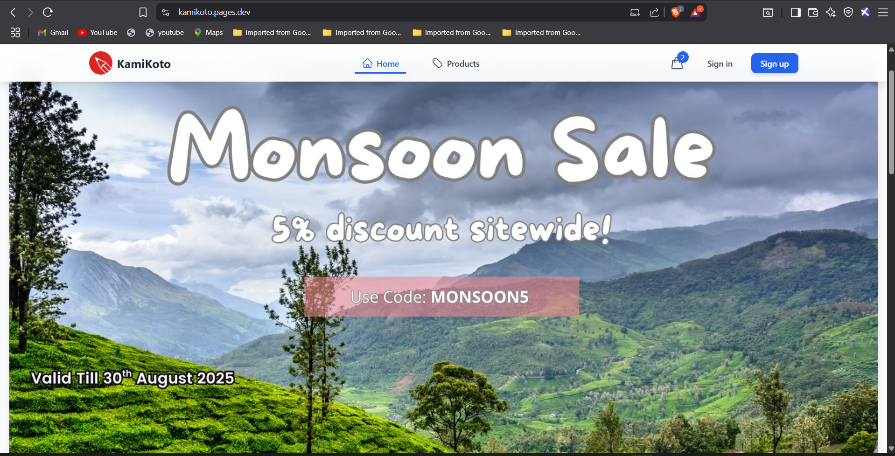

**Functional Modules Overview:**

| **Module** | **Description** |
| --- | --- |
| Home Page | Features highlighted products and promotional banners. |
| Products Page | Displays the complete product catalog with real-time data. |
| Shopping Cart | Reflects current items selected for purchase and allows updates. |
| User Authentication | Includes registration, login, and password recovery screens. |
| User Profile | Enables users to view orders and update personal details. |
| Admin Dashboard | Provides administrative controls for managing products and users. |

**Project Link:**

**GitHub Repository:** [https://github.com/VasthaviSreya-Thumu/kamikoto](https://github.com/VasthaviSreya-Thumu/kamikoto%20)

**Testing and Validation:**

* The platform is validated across major browsers including Google Chrome, Firefox, and Microsoft Edge.
* Layout responsiveness tested across various screen sizes and resolutions.
* Product availability status is synced with Firestore in real time.
* Authentication flows were tested with multiple user types.
* Email dispatch tested using live Cloudflare Worker functions and valid Resend credentials.
* Firestore security rules were implemented and reviewed to protect user data integrity.

**Conclusion:**

KamiKoto is a modern, scalable, and production-ready stationery e-commerce platform built with a focus on clean design, modular architecture, and real-time interactivity. The project reflects an in-depth understanding of frontend development, backend integration, and user experience design. With room for additional features such as payment gateway integration, order tracking, user reviews, and delivery notifications, KamiKoto serves as a solid foundation for future commercial expansion. It stands as a testament to collaborative software engineering and proficient use of current web technologies.